

**Hillingdon Grange School**



**Curriculum**

**Policy**

**Policy Folder:**

**Curriculum**

**Document History**

|  |  |  |  |
| --- | --- | --- | --- |
| **Version** | **Comments/amendments** | **Name** | **Date** |
| 1.0 | Re-formatted, updated and re-issued. |  | January 2025 |
| 1.1 |  |  |  |
| 1.2 |  |  |  |

*“In special education, there's too much emphasis placed on the deficit and not enough on the strength.”*

*Temple Grandin*

**CONTENTS**

**Introduction 4**

**1.1 Aims 5**

**2 Implementation: - 6**

**2.1 Teaching and Learning 6**

**2.2 Curriculum design 8**

**2.3 Therapeutic approaches 9**

**Communication and interaction 9**

**Psychotherapeutic 10**

**Sensory and Physical 11**

**2.4 Lesson Structure 11**

**2.5 Planning 11**

**Adaptive Teaching 12**

**Personalised learning Goals (PLG) 13**

**Behaviour Support Plans 13**

**Assessment for Learning 13**

**Feedback and Marking 13**

**3 Impact 14**

**3.1 How assessment is made 14**

**3.2 Measurement descriptors: 14**

**3.3 Reporting 15**

**3.4 Quality and Assurance 15**

**Social, Moral, Spiritual and Cultural Education 17**

**Fundamental British Values 17**

**3.5 Legislation 18**

# Introduction

The purpose of this document is to provide a comprehensive overview to share with staff, governors, other professionals, families and other interested stakeholders.

The document incorporates our philosophy, aims and values as well as describing the approach to our curriculum, the content and the specialised approaches required for teaching the pupils at Hillingdon Grange.

**Curriculum INTENT:**

At Hillingdon Grange School Primary (specialist provision), we envision a vibrant learning environment where every learner is empowered to discover their unique voice and develop the confidence to express themselves authentically. Our curriculum aims to cultivate a culture of independence, where learners are encouraged to take ownership of their learning and actively engage in self-directed learning experiences. Through a supportive and inclusive environment, we prioritize the development of effective communication skills, fostering the ability to articulate thoughts, collaborate with others, and navigate diverse perspectives. By nurturing independence and communication, we prepare our learners to thrive ensuring they are equipped with the skills and confidence to succeed in their future endeavours.

Our learners present with a variable profile in line with their own individual learning styles. Our curriculum measures progress with engagement schemas to demonstrate the important progression steps our learners require. There is flexibility within the pathways to allow pupils to exceed and reach their potential.

**Hillingdon Grange School prides itself on:**

- supporting children into, and fostering positive attitudes towards, successful educational experiences

- integrating therapeutic and academic approaches

- improving children’s notions of self-confidence, self-worth and self-awareness

- nurturing confidence, resilience and reflection

- developing effective and personalised strategies to support emotional and sensory

regulation

- promoting strong mental health and wellbeing

- providing a secure foundation from which children can continue the next stage of their education whatever that maybe.

## 1.1 Aims

At Hillingdon Grange School our personalised curriculum in designed to offer our children a wide range of learning experiences including the national curriculum plus the wider curriculum which focuses on the ‘whole child’ which aims to address their learning barriers and needs in order to prepare them for the next stages of their education, wherever that may be, their life outside of school and ultimately their adult life.

In thinking about the curriculum design and delivery, we have taken note of parents’ views and priorities for their children through Initial Contact, Pastoral meetings, EHCPS, Annual Reviews and conversations on Pupil Review days. Therefore, through our curriculum we aim to develop portable and transferable skills for all children in the following areas; Communication, Social interaction, independence, personal safety, movement and motor skill, self-regulation, literacy, numeracy, & using ICT as a tool.

The Curriculum at Hillingdon Grange School is broad and balanced and is designed to meet the needs of all our pupils. Following four distinct pathways; the curriculum is carefully sequenced to ensure each child is ready for the next stage in their education. It is differentiated and personalised which makes progression possible for each child preparing them for future life, and promoting their spiritual, moral, cultural and social development. At Hillingdon Grange we know that each child is starting their learning from a different point due to their own particular needs. We recognise that our pupils can have a spikey profile and will develop and progress at different rates.

Pupils and students will receive and develop:

* A firm grasp of basic skills through the teaching of individualised curricula including the National Curriculum.
* The stimulus of a broad and balanced curriculum that introduces new ideas and experience to all.
* Respect and consideration for theirs and others individuality, particular backgrounds, cultures and religions as reflected in the inclusive ethos and multicultural nature of the school; and in preparation for life in a diverse society.
* A curriculum that promotes and supports development and understanding of fundamental British Values.
* The confidence that comes when achievement is recognized.
* The benefits of learning and growing in a calm, friendly, stable and structured environment.
* An education which prepares them for successful, inclusive, enjoyable, rich and active lives.
* An education which gives them high expectations for their future.
* A curriculum that builds on a variety of approaches to learning and teaching.
* An education that allows development and expression through creative opportunities.
* An education that uses real experiences as a foundation for learning.
* A curriculum that supports the physical, emotional, moral and spiritual development of the child.
* A curriculum which aims to give them skills for life, integrating in the local community and being a part of society.

# 2 Implementation: -

## 2.1 Teaching and Learning

Teaching at Hillingdon Grange School is the practice carried out by all staff to ensure all students acquire knowledge, skills and understanding as they progress through a curriculum designed to meet their special educational needs. This practice is multi-sensory, language-centred and connective. Learning is the process through which the students can develop their knowledge, skills and understanding to the point where they have retained and generalised what has been taught.

Teaching and learning is carried out in a context which is relevant and meaningful to all students on the autism spectrum to ensure effective learning and appropriate accreditation.

All staff will work in such a way that the learning environment is one which is calm and consistent, with clear expectation, both as a group and as individuals. This will maximise information processing throughout each day allowing the students to realise their full potential. The curriculum design across all age ranges connects each student with the acquisition of knowledge, skill and understanding related to minimising the effects of a diagnosis of autism and its associated learning difficulties. This design makes meaningful connections for students which maximises their potential for success, access and independence.

**Our 4 pathways**

**Explorers**

Early Years Foundation stage curriculum.

The Early Years Foundation Stage curriculum creates a structure that enables children to work through the various strands at an individual pace. Many of the children who attend Hillingdon Manor are unable to meet the early learning goals by the end of the Reception Year due to their special educational needs. In such circumstances early learning goals continue into Year 1. Children who meet the expected early learning goals will move onto the next pathway.

**Discoverers**

Key Stage 1, 2 and 3 pathway adapted cross linking pathway curriculum emphasising life skills.

Equals Adapted National Curriculum for pupils not yet working at National Curriculum Stages. Discoverers have complex learning needs and a combination of high sensory / processing / communication / interaction difficulties. The focus is on developing the key skills of communication, cognition, independence, sensory and emotional regulation and personal care in an engaging and stimulating environment. Learners on this will benefit from continued access to life skills learning and may, at later stages, access supported living.

**Adventurers**

Key Stage 1, 2 and 3 Adventurers pathway adapted cross linking pathway curriculum.

Equals Adapted National Curriculum For pupils not yet working at National Curriculum Stage.

Pupils may still present with severe learning difficulties but due to their learning styles, some learning may step into more demanding areas of academics. ​The pathway focuses on engagement with learning in options which may be linked to employability, their special interests whilst focusing on specific skill development. Adventurers have an inconsistent profile and learn best through a combination of experiential learning and a topic-based approach.

**Pioneers**

Key stage 2 and 3 Pioneers pathway (national curriculum) adapted and tailored to individual needs.

Rising Stars Progression Framework for pupils working at National Curriculum stage. The Rising Stars Framework allows tracking of progress through regular formative assessment.

Pupils have developing communication, social and interaction skills. They have a more consistent learning profile and are able to access a range of adapted National Curriculum subjects for their Key Stage. The pathway aims to develop higher order thinking skills, functional skills, employability and independence skills. Pioneer learners are able to access lessons delivered in a more traditional format and due to better self-regulation and cognition skills.

## 2.2 Curriculum design

Hillingdon Grange School does not feel that the National Curriculum is able to fully meet the holistic needs of our pupils. All children attending Hillingdon Grange School have an Education, Health and Care Plan (EHCP), which divides pupils’ needs into four areas. Unlike the National Curriculum, our curriculum mirrors these areas (see below).

We have an integrated curriculum that is broad and balanced, and integrates therapy, wellbeing, and academic learning. By design, we have our own in-house therapists (SaLT, OT and Psychotherapy) working closely alongside experienced teachers. In addition to our knowledge and expertise, which is continually evolving, we have drawn on best practice from respected sources to develop our new curriculum. These include, amongst others: The Autism Education Trust, The Centre for Literacy in Primary Education, The Zones of Regulation, Social Thinking, White Rose Maths Hubs, The Lego Education Trust and The Forest School Association. Drawing on a wide pool of evidence-based approaches has allowed us to create a curriculum that we feel best meets the holistic needs of our pupils.

## 2.3 Therapeutic approaches

When deciding on each pathway consideration is given to where the child is positions on the therapeutic pyramids.

## Communication and interaction

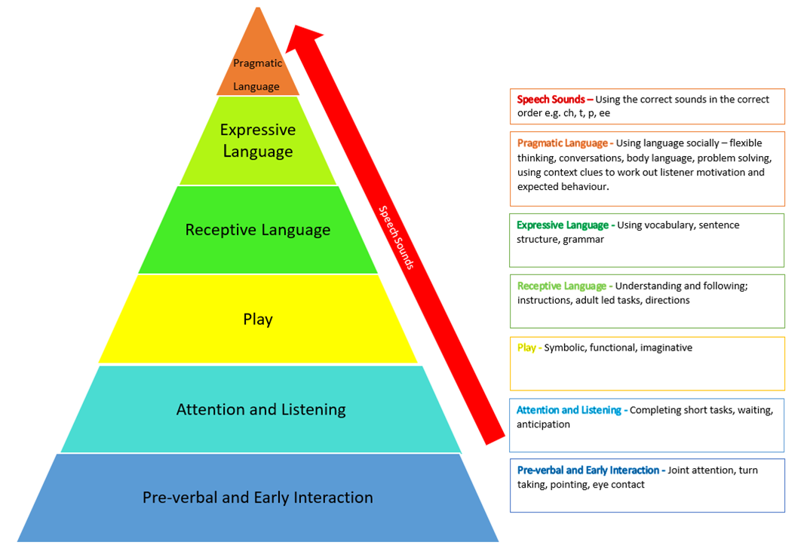

## Psychotherapeutic

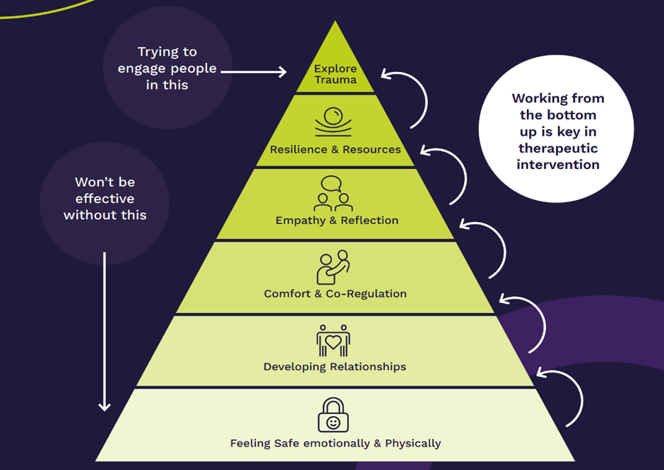

## Sensory and Physical

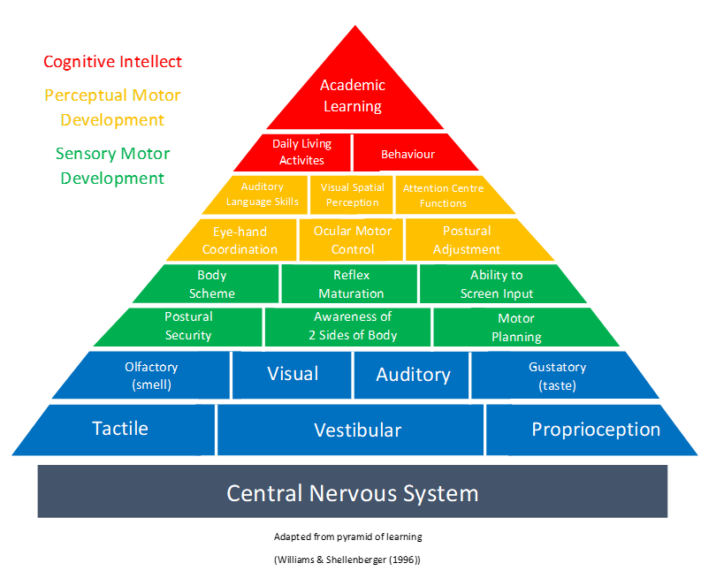

## 2.4 Lesson Structure

Lessons vary in length depending on the subject taught and needs of the class. Practical subjects often require longer sessions, whereas discrete skills can be delivered through carousels or short interventions. The school believes it is important to offer children a curriculum that is broad and balanced in line with our aims and objectives.

Each class constantly adapts and responds to the needs of the children. This may require the use of a more personalised timetable that blends cognition and learning, communication and interaction, and sensory and physical skills to support the children with their SEMH needs, and other needs identified on their EHCPs. Staff are trained, and undergo ongoing CPD, to promote a therapeutic and nurture informed approach to support children in developing their self-esteem and desire to learn.

## 2.5 Planning

We have developed a whole school approach to long term topic-based planning. Classes cover three cross-curricular topics each year to promote breadth and depth of content and so that no pupil – no matter when they join the school – will duplicate a topic. Moving to a whole school, topic-based approach has numerous benefits:

- It allows for our therapy team to work alongside teachers in an efficient way

- It encourages a sense of whole school community

- It fosters collaboration and sharing between pupils and classes

When required, teachers may follow the Recovery Curriculum model to support children, particularly in response to the Covid Pandemic, or significant disruption within a class group. Therapeutic outcomes are planned for and delivered by the therapy and wellbeing team, or shared with the class teacher. Curriculum planning is the responsibility of the teaching staff as directed. Teachers follow a master long term curriculum topic document; medium term planning is completed collaboratively as a staff team; short term/weekly planning is completed by class teachers. All weekly plans have learning objectives, learning activities and differentiation outlined. Where appropriate, teachers identify specific assessment strands that are being evidenced. Planning is monitored on a termly basis by SLT and feedback given. The school has well-developed knowledge and skills progression documents covering reading, writing, maths, science, the arts, and the humanities to ensure that all pupils are working on appropriate next steps, regardless of their starting point.

## Adaptive Teaching

Differentiation, as described in the DfE Teacher Standards, consists of adapting teaching to respond to the strengths and needs of all children, using approaches which enable children to be taught most effectively. Most importantly for HGS, this involves demonstrating an awareness of the physical, social and intellectual development of children, and know how to adapt teaching to support children’s education at different stages of development.

At Hillingdon Grange School, we use a range of adaptive teaching techniques, including adaptation by outcome, by task (including the use of IT resources), by resource, and by the level of support. Adaptation also includes strategies and interventions to support specific educational needs of children. Wherever possible, learning is personalised for individual children. At Hillingdon Grange School, we understand that we are dealing with a group of diverse individuals, who have often had negative past educational experiences, and adapt our teaching to ensure that all of them have access to learning that is meaningful. This is an ongoing and flexible process. Pupils have an initial baseline assessment against which increments of progress can be measured. In short, adaptive teaching shifts the focus from teaching an individual subject to teaching the individual children.

## Personalised learning Goals (PLG)

The PLG is prepared by the children’s class teacher in collaboration with the therapy team, who set SMART targets which are stepping stones to achieving the children’s EHCP outcomes. Each PLG target relates to an EHCP outcome. PLGs contain targets for the following areas: Cognition and Learning (literacy and numeracy), Social, Emotional and Mental Health (SEMH), Sensory and Physical and Communication and Interaction. The targets are monitored and reviewed, and evidence is recorded in the monitoring section of the PLG. PLGs are reviewed on a termly basis and shared with parents.

## Behaviour Support Plans

Wellbeing Support Plans (BSP) are developed alongside children to identify their likes/dislikes, preferences and strategies for emotional regulation. Hillingdon Grange school follows a Zones of Regulation informed approach and children have regular input and opportunities to explore their own emotional wellbeing. See Behaviour Policy for further details.

## Assessment for Learning

Good assessment for learning in the classroom can enhance progress, engage children and help them become more accomplished learners. At Hillingdon Grange School, we use strategies such as clear objective setting; making objectives clear through discussion; written (learning objective/intention clearly written on the board at the beginning of each lesson) or picture prompts around the room and/or in children’s work; revisiting of objectives in relation to tasks and activities that punctuate the lesson. Learning objectives are contained in staff weekly planning and relate to the relevant curriculum framework steps. Success criteria, where appropriate for a given class group, can be used to help children to see where their learning fits, in terms of the bigger picture.

Children take an active role in self-assessment and have a regularly opportunity to reflect on their own learning. Best practice would demonstrate children having the opportunity to evaluate their own work, using assessment criteria (children might know this as success criteria or learning objectives/intentions). Plenary discussions, where appropriate, should allow learners to reflect on (and celebrate) the outcomes they have achieved, what they have learnt, and what next steps they need to follow.

## Feedback and Marking

Written and oral feedback celebrates achievements, but is also constructive by explaining what children have done well, and what they can do to improve (next steps). Best practice would see children taking an active role in their assessment through children understanding the assessment criteria and judging where they are in meeting those criteria.

Pupils’ individual learning needs will be prioritised, therefore in some instances a learner may be using non-prescribed books.

# 3 Impact

As observed in other settings, all staff at Hillingdon Grange school are dedicated to delivering “*the best education for every child*”. Each lesson is another step towards helping our children to achieve the four goals of our curriculum:

* Maintaining positive relationships – developing social skills
* Becoming emotionally resilient – understanding and regulating emotions and building positive coping strategies
* Becoming tolerant and respectful individuals – following Hillingdon Grange School community expectations
* Achieving the best possible outcomes – always doing our best.

We understand the impact skilled Teaching Assistants and Autism Practitioners have on pupil outcomes. They are expected to be fully immersed in the learning experience whilst providing both nurture and structure, alongside predictable routines, expectations and responses to behaviour. Teaching Assistants and Autism Practitioners support teachers in forming a positive learning environment in every lesson and become co-facilitators of regulation and learning.

## 3.1 How assessment is made

At Hillingdon Grange school pupils’ skill proficiency is measured using specific criteria. Our learners present with a variable profile in line with their own individual learning styles. Our curriculum measures progress with engagement schemas to demonstrate the important progression steps our learners require. There is flexibility within the pathways to allow pupils to exceed and reach their potential.

Our strategically planned functional topic cycles incorporate learning steps in a progressional format to include all areas of curricular input: English, Maths, Science, Art, Geography, History, PE, PSHE and RE. Clinical input underpins our teaching and learning; all our individuals have communication and sensory profiles created to support how their learning is delivered. Play is the core to our delivery of teaching and learning; play is deliberate to enable our learners to become successful individuals when they transition to their next phase.

## 3.2 Measurement descriptors:

**Measurement schemas:**

**Immersed**- Pupils may play a passive role in their learning at this stage but will experience and explore the learning intentions.

**Evolving**- Pupils may show increased interest in their learning but will continue to experience and explore the learning intentions.

**Growing**- Pupils will begin initiating an engaging in their learning.

**Maintaining**- Pupils participate in their learning with minimal structure to begin.

**Mastered**- Pupils consistently participate and engage in their learning with growing independence.

Clinical input is significant and underpins our teaching and learning; all our individuals have communication and sensory profiles created to support how their learning is delivered.

## 3.3 Reporting

Alongside the Annual Review document, teachers and therapists contribute to and review pupils’ Personalised Learning Intention Maps (PLIMs). These are shared with parents three times a year, with an annual summative report produced in the summer term. PLIMs and reports detail whether a child is working below individual expected progress, towards individual expected progress, at individual expected progress or above individual expected progress.

Our curriculum framework covers all areas of our curriculum (see above) – these are continually updated and shared with stakeholders at the relevant points.

## 3.4 Quality and Assurance

The Senior Leadership Team (SLT) will:

* have overall responsibility for the monitoring and evaluation of children's progress and achievement
* regularly monitor the school processes for assessing children's performance
* ensure that judgements about assessment are regularly made, moderated and recorded
* that evidence of children's achievement is kept both at the individual child and the subject level
* regularly report to Acorn Care and Education on children's performance
* ensure that Local Authorities, parents and carers receive timely reports on children's achievement
* work with class teachers to develop PLIMs and other plans that inform classroom teaching and interventions and approaches to holistic development
* enable regular reviews against targets set in PLIMs, which consider the range of evidence available of academic and personal progress.

Teachers will:

* contribute to baseline and ongoing assessments
* use subject assessments to inform planning, building assessment into their schemes of work
* contribute to Annual Review reviews
* prepare annual summative reports on children's progress
* report on children's progress in pupil progress meetings
* ensure assessment underpins all lessons
* give effective and meaningful feedback to children
* offer regular written or oral feedback which is positive, explicit about what has been achieved and about next steps
* give children opportunities to reflect on their learning and understand what progression means in that subject
* provide weekly planning, detailing lessons so that support staff can best support the children
* monitor and evaluate children's progress in the classes they are responsible for, and use the findings to inform planning
* be aware of and assess both academic and personal progress

Support staff will:

* be aware of the learning objectives and their specific role within the lesson e.g. working with a target group or specific individuals
* be aware of the assessment objectives for the group or individual that they are working with
* be aware of personal progress (in relation to EHCP outcomes and therapy outcome measures)
* contribute actively to periodic reviews of progress for children.

Therapy and wellbeing staff will:

* contribute to the admissions (and internal referral) process, and take the lead on diagnostic assessment in relation to any therapeutic matter
* play a part in the target setting process, and offer guidance to other staff on how they can support any therapy-related target
* advise education staff on how best to interact with the child in question and enable them to flourish
* conduct appropriate observations and assessments, and contribute formally to reviews.

Children will:

* be able to offer their own views of progress, know what their own targets for development are and understand how they are going to work towards them (in an age-appropriate manner)
* identify meaningful targets that are important to them to achieve
* play an active part in assessing themselves and each other during lessons and at the end of modules of work
* be able to discuss achievements, difficulties and attitudes to learning and contribute to review processes.

Parents and Carers will:

* respond to reports provided by the school
* share their perceptions of progress made and areas for development identified
* be aware of key targets for development set through EHCP and pupil progress review processes, and contribute as actively as possible.

Local Authorities should:

* provide as much relevant information as possible of the child's prior attainment, background, learning and behavioural needs, as they join the school
* play an active part in periodic reviews of progress
* be ready to facilitate additional support (e.g. CAMHS) where this is called for by the review process.

## Social, Moral, Spiritual and Cultural Education

At Hillingdon Grange School we are committed to developing our students Social, Moral, Spiritual and Cultural Education. As part of this provision, we ensure that partisan political views are not promoted in the teaching of any subject. This is closely monitored through lesson observations and monitoring of planning and the curriculum where appropriate.

We understand that our pupils need to be prepared for their lives in modern-day Britain and safely navigate through multicultural society. Pupils are encouraged to participate in whole-school events focusing on character development and resilience-building. Difficult and pressing subjects and concerns are not shied away from but addressed with care, empathy and understanding. The curriculum has been designed in a way that enriches pupils’ cultural capitals through assemblies, collective worship opportunities, educational visits and workshops.

# Fundamental British Values

At Hillingdon Grange School actively encourages pupils to respect the Fundamental British Values of democracy, the rule of law, individual liberty and mutual respect and tolerance of those with different faiths and beliefs, throughout the curriculum delivery, teaching and learning in the school. These values underpin all teaching and learning at the school. They are also explicitly taught through assemblies, through the students taking an active role in the school council. The latter focuses on removing social barriers to being a fully functional and active citizen: developing friendships, managing conflicts, understanding responsibilities, establishing healthy boundaries and co-existing in a diverse and fast-paced society.

## 3.5 Legislation

This policy is designed to ensure that the school complies with, and exceeds, the expectations of all relevant legislation. We commit to meeting and surpassing the principles set out in [The Education (Independent School Standards) (England) Regulations (2019)](https://assets.publishing.service.gov.uk/government/uploads/system/uploads/attachment_data/file/800615/Independent_School_Standards-_Guidance_070519.pdf), [Education Inspection Framework](https://www.gov.uk/government/publications/education-inspection-framework/education-inspection-framework-for-september-2023), [Equality Act 2010](https://www.gov.uk/guidance/equality-act-2010-guidance), [RSE and Health Education Guidance](https://assets.publishing.service.gov.uk/government/uploads/system/uploads/attachment_data/file/1090195/Relationships_Education_RSE_and_Health_Education.pdf), and [Improving the Spiritual, Moral, Social and Cultural Development (SMSC) development of pupils 2013 (supplementary information 2014)](https://dera.ioe.ac.uk/id/eprint/21502/1/Improving_the_spiritual__moral__social_and_cultural__SMSC__development_of_pupils_supplementary_information.pdf) with regards to:

**Curriculum:**

1. full-time supervised education for pupils of compulsory school age (construed in accordance with section 8 of the Education Act 1996(1)), which gives pupils experience in linguistic, mathematical, scientific, technological, human and social, physical and aesthetic and creative education;
2. that pupils acquire speaking, listening, literacy and numeracy skills to the standard expected of pupils nationally, or are working to close the gap;
3. where the principal language of instruction is a language other than English, lessons in written and spoken English so that pupils achieve the fluency of pupils nationally in speaking, reading and writing English;
4. where a pupil has an Education, Health and Care Plan, provide an education which fulfils its requirements;
5. reflects the school’s aim and ethos;
6. encourages respect for other people, paying particular regard to the protected characteristics set out in the Equality Act 2010;
7. that all pupils learn and make progress from their starting point;
8. effective preparation of pupils for the opportunities, responsibilities and experiences of life in British society by explicitly teaching and promoting British values of democracy, the rule of law, individual liberty.

Teaching:

1. enables pupils to acquire new knowledge and make good progress according to their ability so that they increase their understanding and develop their skills in the subjects taught;
2. foster in pupils self-motivation, the application of intellectual, physical and creative effort, interest in their work and the ability to think and learn for themselves;
3. involves well planned lessons and effective teaching methods, activities and management of class time;
4. shows a good understanding of the aptitudes, needs and prior attainments of the pupils, and ensures that these are considered in the planning of lessons;
5. demonstrates good knowledge and understanding of the subject matter being taught;
6. utilises effectively classroom resources of a good quality, quantity and range;
7. demonstrates that a framework is in place to assess pupils’ work regularly and thoroughly and that pupils make good progress because teaching is planned using information from those assessments;
8. utilises effective strategies for managing behaviour and encouraging pupils to act responsibly;
9. does not undermine the fundamental British values of democracy, the rule of law, individual liberty and mutual respect and tolerance of those with different faiths and beliefs (Improving the spiritual, moral, social and cultural development (SMSC) development of pupils 2014);
10. does not discriminate against pupils contrary to Part 6 of the Equality Act 2010.

We also commit to meeting and exceeding the expectations set, with regards to the Spiritual, Moral, Social and Cultural development of our pupils. We will actively [promote the fundamental British values](https://assets.publishing.service.gov.uk/government/uploads/system/uploads/attachment_data/file/380595/SMSC_Guidance_Maintained_Schools.pdf) of democracy, the rule of law, individual liberty and mutual respect and tolerance of those with different faiths and beliefs and will ensure that principles are promoted which:

1. enable pupils to develop their self-knowledge, self-esteem and self-confidence;
2. enable pupils to distinguish right from wrong and to respect the civil and criminal law of England;
3. encourage pupils to accept responsibility for their behaviour, show initiative and understand how they can contribute positively to the lives of those living and working in the locality in which the school is situated and to society more widely;
4. enable pupils to acquire a broad general knowledge of and respect for public institutions and services in England;
5. lead to further tolerance and harmony between different cultural traditions by enabling pupils to acquire an appreciation of and respect for their own and other cultures;
6. encourage respect for other people, paying particular regard to the protected characteristics set out in the Equality Act 2010;
7. encourage respect for democracy and support for participation in the democratic processes, including respect for the basis on which the law is made and applied in England.

We will preclude the promotion of partisan political views in the teaching of any subject in the school and take such steps as are reasonably practicable to ensure that where political issues are brought to the attention of pupils, they are offered a balanced presentation of opposing views:

* while they are in attendance at the school;
* while they are taking part in extra-curricular activities which are provided or organised by or on behalf of the school;
* in the promotion at the school, including through the distribution of promotional material, of extra-curricular activities taking place at the school or elsewhere.

As part of the school's curriculum development process, a variety of existing curricula were examined so that informed decisions could be made.

