Request for Authorised Absence for a Pupil

If you are needing to take your child out of school during term time, please complete the form below to request authorisation. This is not needed for medical appointments etc.

We kindly ask you to provide the details of the absence so that we can consider the request in line with our attendance policy. Absence during the school term can only be authorised in exceptional circumstances.

Absence Request Form

Child’s Full Name
Class/Site:
Proposed absence start date:
Proposed absence end date:
Total number of school days absent:
Reason:

Please return this completed form to the school at least 20 days prior to the leave of absence. We will notify you in writing once the request has been reviewed.

Thank you for your cooperation.

Regards,
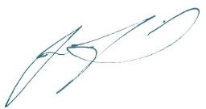
Julie Field
Hillingdon Grange Headteacher

